Norwich CanoeClub
Committee Meeting
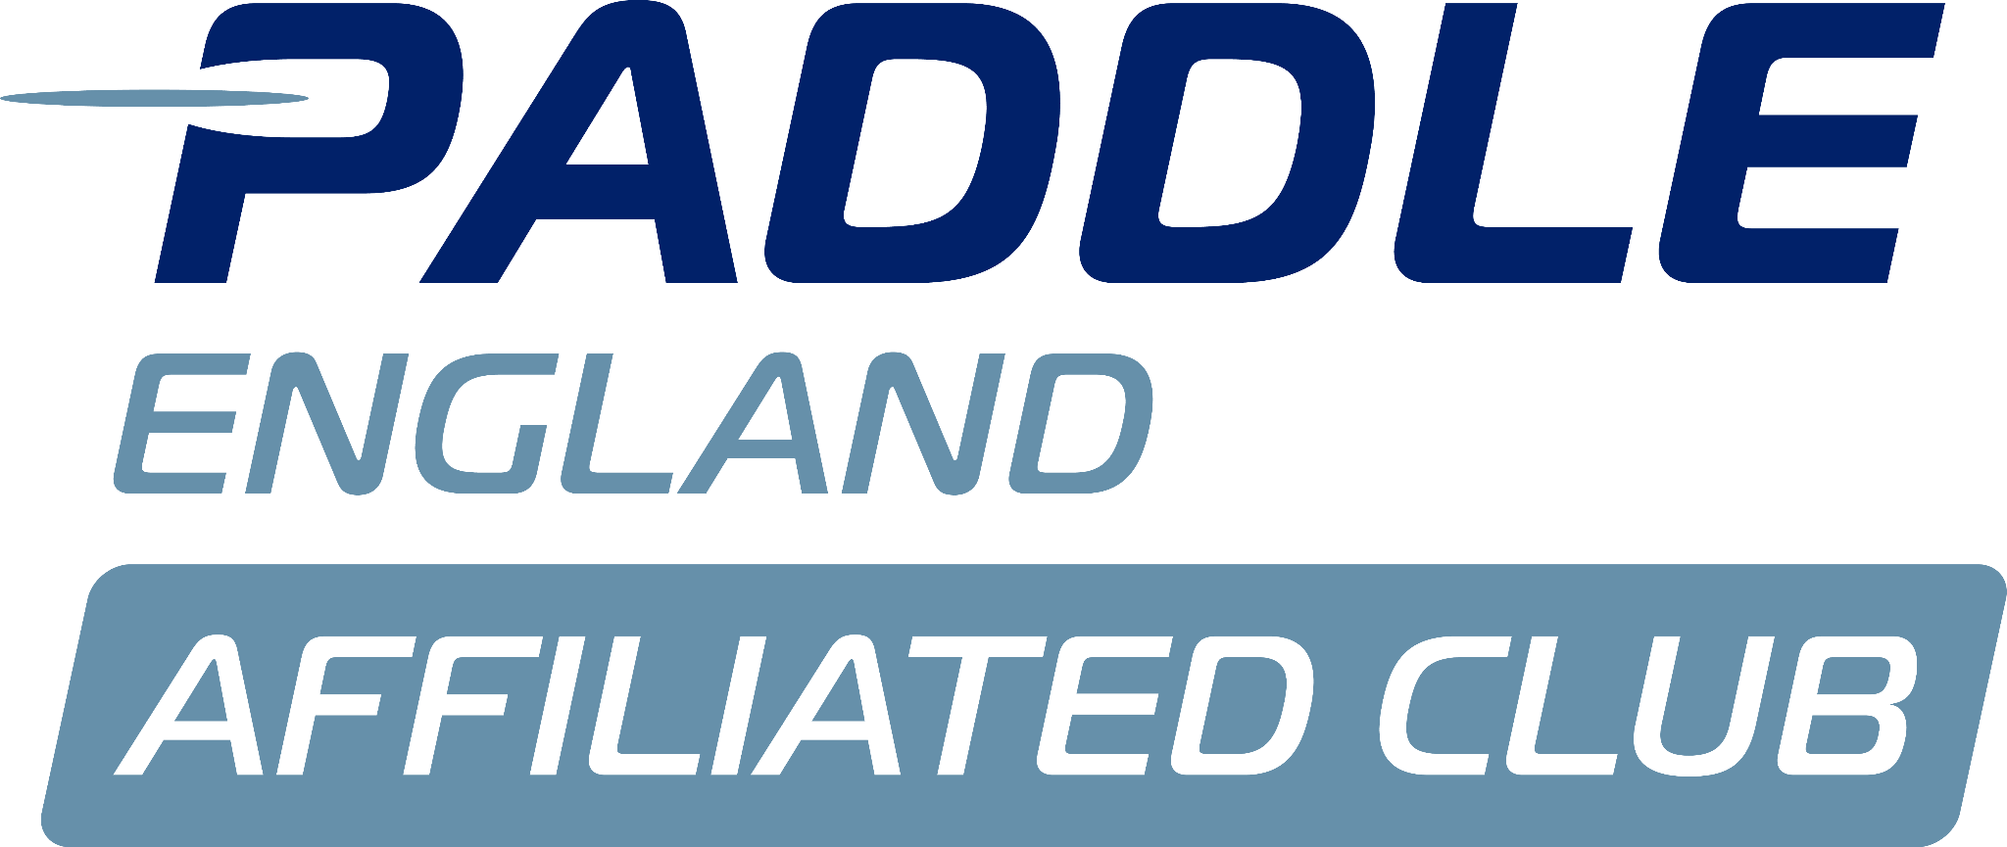
Monday 8th September

Louise attended this committee meeting to provide feedback on the summer LTK and her suggestions for the winter and next year. All agreed the summer has been very successful.
Still looking at the primary function of the LTK role to be to gain members, as long as the courses cover there costs they are there to feed the club with new members.
The committee recognises that the LTK role is a critically important coaching role in the club as it is the one that feeds the membership.
- Talking to Louise about the summer and older adult group. This has been successful but Louise found that we were not really set up session wise to take recreational paddles. There fore all agreed that Tammy can take this older adult group around the island – Tammy has been deemed competent to do this by Dyson. Thank you Tammy for volunteering to do this.
- Beginner boats need more attention as they are battered. The beginner boat fleet is not being maintained well enough and this is leaving some Sat AM sessions short when they are well attended. We have enough boats if all are in good working order, but with the amount out of action as has been lately this has made some sessions difficult. Dyson has spent some time repairing boats but we need to stay on top of this more. Sarah to instruct Phil to continuously repair the beginner boat fleet over the course of the winter ahead of next years LTK courses.
- Need a structured coach for each group on a Wednesday. The Wednesday night sessions have been a problem throughout the summer as they are really well attended without enough volunteer coaches. Action Dyson next coaching meeting.
- Put a message out to see if anyone wants to coach again Action Megan please do a call for coaches on a Saturday AM and Wednesday PM session
- Louise has made contact with Open Age for further courses to run next year. Thank you
- We talked about what further off the water offering there could be over the winter. Louise is a qualified life guard and we could therefore offer pool sessions. Action Louise.
- October half term non paddling week. Louise will organise
- We need some more buoyancy aids. If we need more buoyancy aids Louise to go ahead and order what is needed.
- Louise asked if we could name the lightnings animals. Committee agreed

Christmas awards
A concern has been raised around access and egress of our awards evening due to the para paddlers that we have.
Sarah Walker spoke with Tim Scott, the awards evening will be in the Chapel again in 2025 but Tim has agreed to look for alternatives from 2026. Tim will liaise with the para paddlers to ensure that access/egress can be offered. Only one paddler impacted by the choice of location. Redwell suggested but not felt to be the correct venue for awards evening.
Lousie & Matt lodge are looking at Christmas parties for 2025 with a family feel at the club house . Louise is going to sort and will update at next meeting.

AGM 22nd November
The committee recognises that we are not yet ready for Aaron to leave us !! We would like quotes for accountancy services. . Anna Action.
Vacant seats below
Chair
Treasurer
Health and Safety
Welfare
Social do we need it. A conversation was had around combining some of the roles as the committee was very large, volunteers can help as and when needed.
Agree to combine Marketing ,social media and social pulling in people to help.
Para – can become a non committee role with a para providing representation to the committee regularly to provide feedback on the programme. Megan action asking a para paddler to attend a committee meeting once a quarter to provide feedback on what we offer.
Digital. Do not need role. Look at my clubhouse this can provide most or all of what we need.
The committee reviewed the current committee/trustees structure and agreed to suggest that this was combined once more. Overall feeling is that the club is not big enough to warrant a two tier structure, what was needed was a cohesive committee that worked together to drive change. Therefore we agreed that Sarah would put forward the recommendation that the trustees combine with the operational committee.
There is no legal reason that we could find that these two must remain separate.
Include in AGM pack.
Ask Sam who can host the club website.
Yes to Sam putting program on website.
Discussion on the two roles. All agreed that the LTK role was a critical position to the club as its primary function is to gain membership. There has been documents circulated with changes to both the Junior and LTK roles; Norwich Community Coach role and Junior and Under 23 role documents apply.

Committee agreed that we should move forward with the suggested changes.
Dyson advised that the club owns a Launch – that needs fairly substantial repair.
Check with Jackie where this can be moored and if there are any costs involved.. Action Aaron

There was no other business.
End of meeting, next meeting 13th October.

