Norwich CanoeClub
Committee Meeting
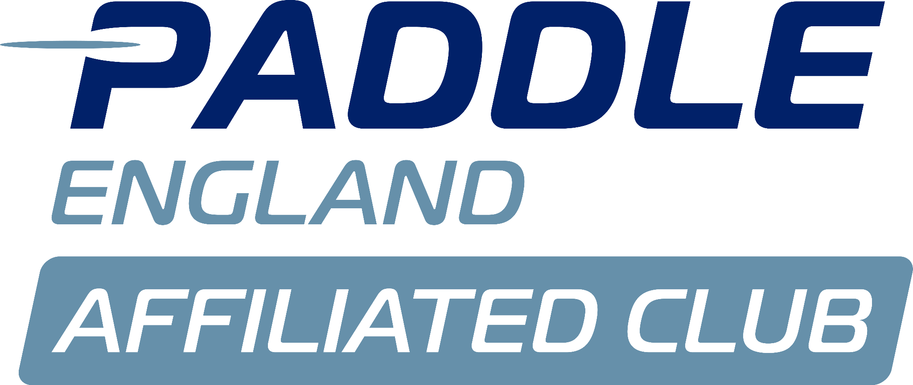
Monday 13th October

Present:
Sarah Walker
Charlie Peck
Anna Carrington
Matthew Lodge
John Frankland
Aaron Widdows
Tammy Edwards
Terry Epps(Trustee)

Apologies:
Megan Broadey
Dyson Pendle
Steve McAulay (Trustee)

Previous minutes
Terry stated he would flag as a concern at the next Trustees meeting that he didn’t agree with the process of looking to appoint and pay for an external accountant to look after the charity accounts. SW explained that we were only costing at the moment. Aaron confirmed that he has agreed to stay on as Treasurer for another year while we look into what to do next.

Aaron highlighted the potential health and safety aspects and insurance of owning a launch. Also should there be a policy for use?
- ACTION.

Other points on minutes agreed.

Membership

There are still some members whose subs aren’t up to date. Committee agreed that those members who haven’t paid any subs will receive a final reminder email to pay by the end of November or contact to set up a payment plan. If no payment is received their membership will be terminated and their boats removed.

TE reported on the number of current members which is the highest for a few years.

- ACTION: TE to check subs paid and issue any reminders.

Finance

Aaron presented financial accounts.
We have a net surplus of £2494.53

Tim had provided a Norwich paddler with a free place at JDS camp - this was because he needed a helper and/or to fill a k2 seat because of uneven numbers. It was felt this was not inclusive and that if he is going to invite NCC members to help or fill a K2 seat, they should pay £5 a session.

Aaron is still awaiting an invoice from Boathouse and has asked but still not received.

As we have funds, Aaron suggested asking relevant coaches/committee what their wish list is - what is needed?

Sarah is going to order 4 x k2 bags and 6 x k1 bags from Kirton.

ML asked if the club owns all the boats in the boathouse, ie, the para boats?
- ACTION: Matt will ask Tim if any of the boats are on loan?

Sprint fees outstanding and no-one atm to follow up collecting fees.
- ACTION: Aaron will send list of outstanding amounts to committee who will take a few names each and email those people.

Barclays not implementing mandates - new mandate signed this evening - Terry to post to bank.

Following queries previously about how the Trustees and Operational Committee operate, and their differing roles, Aaron has produced a diagram showing how different groups are responsible for different areas - roles of Trustees / Coaches / Committee / members.

Discussion about communication between Committee and Trustees - the Operational Committee had requested that the Trustee and Committee meetings be combined to improve communication and ensure correct governance.

AW said not practical to combine meetings as Trustees have a full agenda of Charity Governance. It would be too onerous for Trustees to also attend Committee meetings.
JF stated that it’s important for governance to be separate from committee.

SW stressed that there are certain issues where Trustees help has been requested but not responded to. Terry was unsure what these problems were - SW stated that numerous emails had been sent and not replied to.
AC suggested that without a Chair (potentially no Chair next year) and without input from Trustees, there will be very little that committee can do.
Terry stated that as Trustees they are happy to have a meeting with Sarah in the next couple of weeks to discuss any urgent points. SW asked Terry to provide some dates which would be suitable.
- ACTION - Terry to provide SW with meeting dates.

Coaching

Andy Ross brought up issue of enough coaches on Saturdays.

- ACTION: who?
Go to coaches and ask for more saturday coaches
Ask Coral how she does kitchen rota - who is included / not included?

- ACTION: who?
Get more people on Paddlesport Leader training in readiness for assessment next year.

Portage
£5,500 needed to draw up a 10 year lease with Mills and Reeve/Crown Point. Overall cost to club will be £7500.
SW will retain job of finalising portage beyond her Chair role.
This will enable us to continue running National and possibly International events.

- ACTION: AW pointed out that the lease should be with the Canoe Club not with the Boathouse. SW will go back to them about this.

- ACTION: AC suggested that she knows a solicitor who may be willing to independently review the lease to make sure it’s ok.

Christmas party
ML advised a provisional date of 13th December.

My Clubhouse
Tammy will organise the month free trial when there is time to make full use of this.
- ACTION: Tammy will arrange an online demo and let others know so they can join in.

Membership increase
The trustees will advise if we’re agreeing membership fees at the November agm or calling an extraordinary meeting before July.

End of meeting, next meeting 10th November.

