

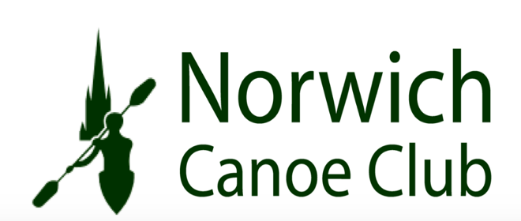
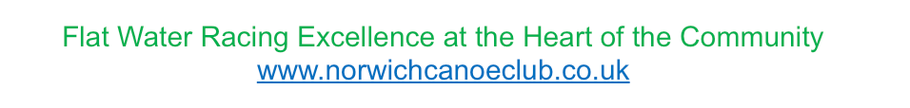
Norwich Canoe Club
Committee Meeting
Monday 10th November 2025

Present:
Sarah Walker
Charlie Peck
Dyson Pendle
Aaron Widdows
Matthew Lodge

Apologies:
Megan Broadey
Anna Carrington
John Frankland
Tammy Edwards

Previous minutes:

No issues raised over and above ongoing actions

Membership:

Tammy is not available for this meeting.

Noted there are now 201 members within the club.

Ongoing issue with members subs not up to date to be addressed by Tammy.

ACTION- Tammy to update at next meeting.

Finance:

Financial report from Aaron advised £97,000.00 in the bank on a cash basis.

Boathouse fees have come in are around £25,000.00 for the year

Portage works have received planning, and deposit has been paid for the works

Club agreed to buy K2 from Dyson - £1,000.00

Sarah has purchased K1 & K2 boat bags

Noted by Dyson that repairing the launch will be around £200.00 (Approved)

ACTION- Noted by Aaron that we need to spend cash and coaches to look at boat requirements and discuss at next coaches meeting. Aaron to look at Sprit fees.

Coaching:

Noted more coaches are needed on a Saturday morning. It is to be looked at how we get more people involved and put on the Paddle Sport Leader Course.

Tims report to be looked at with him and make sure everything is covered. (Reports & Hasler / National events) – SMcA to speak with Tim and discuss at future committee meeting.

Look at Sport England Report – SMcA

Oxygen Advance Courses have been lottery funded – SMcA to speak to Tim regarding delegates.

Psychology course and speaker to attend day of the awards night and deliver talk and present the awards at the evening event in the Cathedral Chapel.
Food for the evening to be looked at by Sarah

Tim to go ahead with grant applications (£949.00)

Agreement to spend £600.00 on smaller paddles – SMcA to speak to Tim on grant application

BUCS entry packs to be produced and out before Christmas.

ACTION- Matt and Tim to collate list of existing coaches and potentials and discuss with SMcA.

Portage:

Planning approval received and deposit paid. Sarah to continue to drive the project forward with the support of SMcA

ACTION- Sarah and SMcA to meet to discuss next steps.

Christmas Party:

Arranged for 13th December from 16:00 – late

My Clubhouse:

Note carried forward form last month – Tammy to organize month free trial when the time is correct to utilise the system.

ACTION- Tammy to undated at the next committee meeting

AOB:

- Noted Dyson to look at writing a policy for the use of the launch.
- Noted Dyson to look to see if we can get launch license through them
  - Possibility power licenses may be needed.
- Dyson to speak to Lynsey Barker about removing her boat.
- Discussions to be had with Martin regarding the present position with the new pontoon works

Next Meeting: Monday 8th December 18:30 – Clubhouse

