Norwich CanoeClub
Committee Meeting
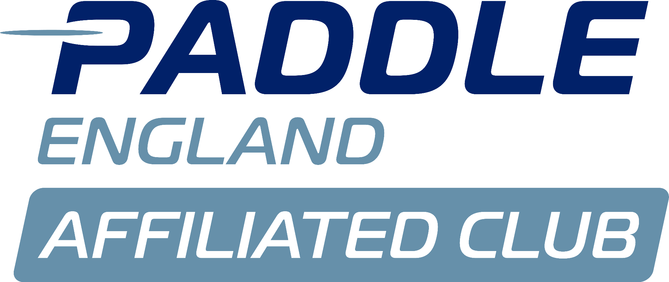
Monday 10th March

Present:
Megan Broadey (MB) Secretary
Anna Carrington (AC) Publicity Rep
Charlie Peck (CP) Adult Rep
Dyson Pendle (DP) Director of Coaching
Matthew Lodge (ML) Vice-Chair
Flo Duffield (FD) Sprint Rep
Sarah Walker (SW) Chair
Aaron Widdows (AW) Treasurer
Tammy Edwards (TE) Membership Rep

Apologies:
Jo Davis
John Frankland
Shaun Cook

Minutes agreed by committee.

No matters arising from previous minutes.

Actions from previous minutes:

Conflict of interest:

Suzanne's Report:
SW- Suzanne stepping down from role.
Committee agreed the role should be advertised internally initially.

Tims Report:
SW- Copy and paste Adult equipment grant for the newsletter. ACTION CP.

Welfare Reports:
ML- What turn around do we want from Welfare officers?
MB- We agreed that they had to check emails once a day.
ML- Not sure that is being met.
SW- Will contact to ask for reassurance they are being checked daily.

Health and safety reports:
SW- Asked Steve to review risk assessment for Hasler/Nationals and BUCS, and he has done it.
DP- Jan has picked up risk assessments for SUPS, she might be willing to pick up that role.
Thanks to Steve Mableson and Jan Alexander for their support with this.

Issues from coaching meeting:
N/A

Membership report:
TE- Been chasing 2024 payments recently. Most people have caught up with payments.
- Have reviewed 2025 payments, quite a few people haven't paid. Will chase them in the next week or so.
- Parking permit email has been sent out.
TE- 15 people haven't renewed this year. 3 new members.

Finance:
AW- Surplus in Feb, however there was a donation From Martin Mathews towards the pontoon. Planning for it has gone in, we need to pay for the planning permission- he has donated £2k+ to get the project moving.
- Nil payment for coaches fees.
- BUCS payments are done.
- £66k cash end of Feb.
- Current account down to £5400, if there are any big costs going out make me aware.
- WBH owes us the cost of ergo screens.
- £1800 paid for Nationals car park.
- Things we have had in advance (annual subs, lottery grant, boat, surfski) Net current asset is £60k.

Objective Meeting:
ML- Any questions on the document that was sent out?
SW- No.
- A member has put forward an objective: Consider paying team leaders in the kitchen, and take this to the boathouse.
- It’s more a question directed at the boathouse.
SW- Will send it to the boat house. ACTION SW to speak to WBH.
CP- Keep Objectives similar to last year so we can compare results.

ML- Date of meeting?
SW- 26th April on teams after Saturday session.Trustees and Tim to be invited.

Bursary:
TE- Main change, was removal of ‘not a home-owner’, streamlined to income below £25,000, only need to meet one requirement. Can only give 66% bursary.
SW- Yes that was agreed in the previous meeting.
AW- Should caveat the £25,000, with not being in full time education.
The committee agree.
SW- What about people with benefits?
AC- It can just be done on a case-by-case basis.

Bursary criteria to be reviewed in 1 year.
The committee agree.

Social Membership:
Move to April’s meeting.

Portage Project:
Move to April's meeting.

Nationals:
Move to April's meeting.
SW- Will be asking for support with running and planning of events.

Website Update:
SW- Can anyone liaise with potential companies to take over this work load (next 6 months).
ACTION CP.

Kitchen Volunteers:
Covered in an Objective meeting.
CP- Not everyone does volunteer, used to be coaches who didn't have to volunteer. But there are now coaches who don’t coach or volunteer in the kitchen.
- The issue isn't new members, it's older members.
SW- Should send email out every 6 months to those who don’t volunteer. Should also encourage newly 18 year olds.
ACTION add to the newsletter.

AOB:
SUP Storage-
ML- New SUP’s ordered that don’t fit. Jackie wants extra £75.
The committee agreed.

Increasing number of disabled spaces-
ACTION ML to contact Jackie asking for more spaces.

