Norwich CanoeClub
Committee Meeting
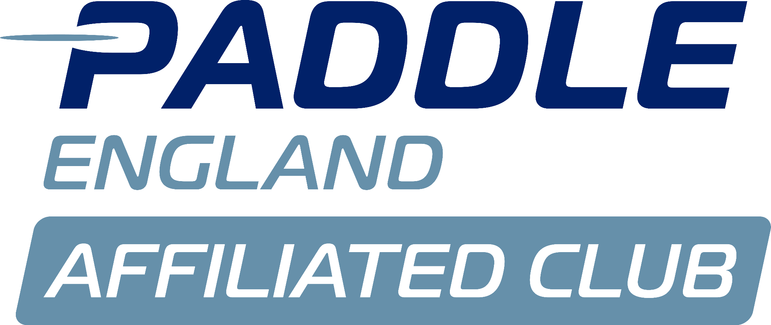
Monday 9th June

Present:
Matt Lodge- Vice Chair (ML)
Dyson Pendle- Director of Coaching (DP)
Charlie Peck- Adult Rep (CP)
Aaron Widdows- Treasurer (AW)

Apologies:
Tammy Edwards
Shaun Cook
Alex Booth
Sarah Walker
Megan Broadey
Anna Carrington
John Frankland

Minutes agreed by committee.

No matters arising from previous minutes.

Actions from previous minutes:
Refer to Megan's list sent out before the current meeting.
- Dyson will sort out tyres for small trailer before 20th June.
- Tim is applying for a grant linked to coaching costs.
- Dyson will chase Phil for invoices for trailer work.
- Dyson questioned - if we take a trailer for servicing to Indespension, will they question what it is? For reference, Phil made the trailer, and he is legally qualified to examine it.
- Aaron spoke to Tim about JDS prices - Tim explained he has to be transparent with Paddle UK so has broken costs down into different areas. Norwich Canoe Club gets a fixed fee [in region of £540] for hosting.

Conflict of interest:
ML- National Merch quotes.

Louise’s Report:
Has everyone read it? YES
Cost of 2-3 day school beginner sessions -
ACTION Dyson to send document over to Matthew which contains agreed costs.

Tims Report:
Dyson to sort out 2 tyres for little trailer.
Matthew to advise Tim about dates for BUCS as Cambridge Hasler is around the same time.
Matthew advised that the performance dept of Paddle UK are interested in getting involved in BUCS.
Aaron - We made £1644 from BUCS last year

Welfare Reports:
N/A

Health and safety reports:
We need a Health and Safety Officer who is a member - it was stated by Matthew that we have granted a free membership to Steve Mableson in return for this role. We discussed this and those present decided to make him an Associate Member, in line with Aaron (treasurer) and Anna (Marketing).

Discussions continued about co-opting committee members mid-term without a vote from the membership. This was discussed and agreed it was ok to do this.

ACTION - Matthew to email other committee members to vote Steve in as committee member as we are not quorate this evening

Risk Assessments
John Frankland is looking into risk assessments, updating those that are needed etc.

Issues from coaching meeting:
N/A

Membership report:
Tammy said that there are still some members not paying the correct monthly amount. She has shared the spreadsheet with all committee members -
ACTION Dyson and Matthew said they would contact those highlighted in red to remind them to update their standing orders and pay any amount due.

ACTION. Tammy will set out costs of subscribing to My Clubhouse and Go Cardless for direct debits, and send this round in an email to vote on as not quorate at this meeting.

Finance:
Accounts as circulated were discussed and explanations given verbally by Aaron.

We discussed the two k2s that are financed through a grant of £6402.
ACTION - Dyson will email the whole Committee to get approval of what to buy, ie can we exclude boat bags and confirmation of other additional extras.

Nationals:
Merch - we are using same supplier as last time - Anna dealing with
Website - Matt P is sorting out
Info Pack - Sarah is working on this
Results - MRC will do
Trophies and medals - MRC will bring
Number Boards - these are at Nottingham, will be brought back at next Regatta or Charlie will collect from Reading

Actions
Matthew will email Sarah for update on pack, Anna re merch and Matt re website.
Dyson will buy some rope
Dyson will check with Sarah about volunteers/staff

Code of Conduct
Needs renewing by end of June. Meg circulated these asking for comments by end of May. Assume these are now agreed.
ACTION: Matthew will speak to Sarah.

End of meeting, next meeting 14th July.

