Norwich CanoeClub
Committee Meeting
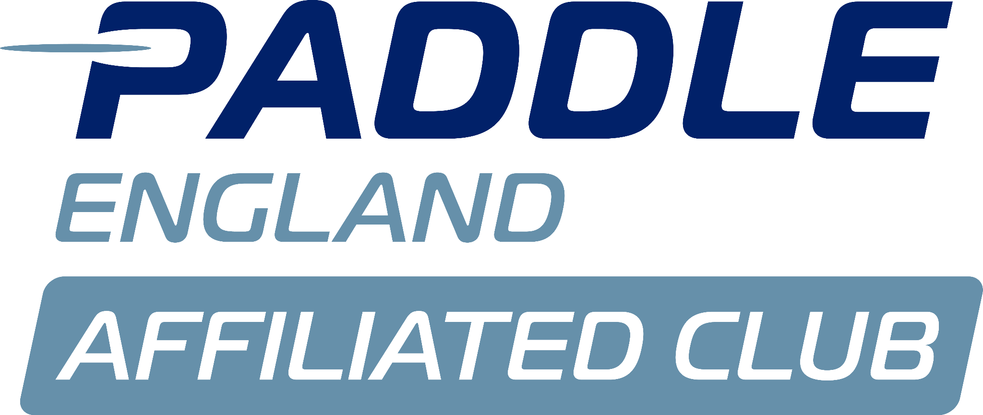
Monday 14th July

Present:
Anna Carrington (AC)
Sarah Walker (SW)
Charlie Peck (CP)
Megan Broadey (MB)
John Frankland (JF)
Tammy Edwards (TE)
Matthew Lodge (ML)

Apologies:
Shaun Cook
Alex Booth
Aaron Widdows
Flo Duffield
Dyson Pendle

Minutes agreed by committee.

No matters arising from previous minutes.

Actions from previous minutes:

Conflict of interest:
ML- Portage Update-

- Louise’s Report:
- No report sent.
- Louise has expressed she won’t currently be continuing the role beyond September- can support with admin if needed.
- SW- Need to review both paid coaches contracts and decide on services required under each role.
- Offer to Louise for first refusal and then recruit externally.
- ACTION SW to put forward suggestions of changes.

Tims Report:
Cambridge Paddler:
- TE- Cambridge paddler attending sessions confirmed non-member.
- SW- Non members may attend up to ⅘ sessions before joining.

Coach Development:
- TE/CP: Have received email requesting payment
- SW- Need to confirm how much we are charging people to attend these courses.
- Committee agree- Course Fee Policy £50 minimum +admin fee for any course over 4 hours.

First Aid:
- SW- Can we ensure the people who have completed the Leadership course are put on this too.
- ACTION ML to book those participants onto the training.

Grant Applications:
- SW to follow up on the grant applications.

Welfare Reports:
- N/A

Health and safety reports:
- Members to be reminded about hygiene- Weils Disease- ACTION include in Newsletter.

- JF- Estelle making a rescue, rowers ores hitting boat being recovered- boat didn’t have much buoyancy.

- ML- Rowers entering the cut at speed- has been raised with their coaches.
- ACTION JF to raise concerns to WBH.

Issues from coaching meeting:
- N/A

Membership report:
- TE- New member from the Norfolk Show.
- Renewals below 50%- follow up is planned for the end of the month.

Finance:
- AW absent.

- TE- MyClubhouse lacks direct debit support- GoCardless may be a better option for membership payments.
- Costs £1000 +VAT- may also save time with L2K bookings.

- New Treasurer required from November as AW steps down.
- ML- Suggested Terry Epps or ML brother- £1,200 +VAT.
- AC- Current business accountant costs £220/month.
- ACTION AC to discuss with AW and seek alternative quotes.

WhatsApp Communication:
- AC- Proposal to use WhatsApp Communities for controlled communication to members.
- Current safeguarding issues with the open WhatsApp group, with new members adding juniors to the group possibly without parental permission.
- ACTION AC to address with member and have admin controls on the group.
- ACTION CP/AC to announce official group via newsletter/socials.

Committee Role Rotation:
- Spreadsheet has been updated.
- ACTION SW to propose revised structure of committee to Trustees.
- Open positions for AGM will be:
Chair
Treasurer
Junior Rep
Marathon Rep
Welfare Rep
Digital Rep
Social Reo
Publicity

Portage Update:
- SW- £10k Canoe Federation grant valid until March 2026.
- Planning permission expected shortly- Crown Point are supportive.
- Broads Authority requires legal agreement for land use/public liability.
- ACTION SW to follow up with Vic Blanchard to see if she would be able to support.

End of meeting, next meeting 11th August.

