Norwich CanoeClub
Committee Meeting
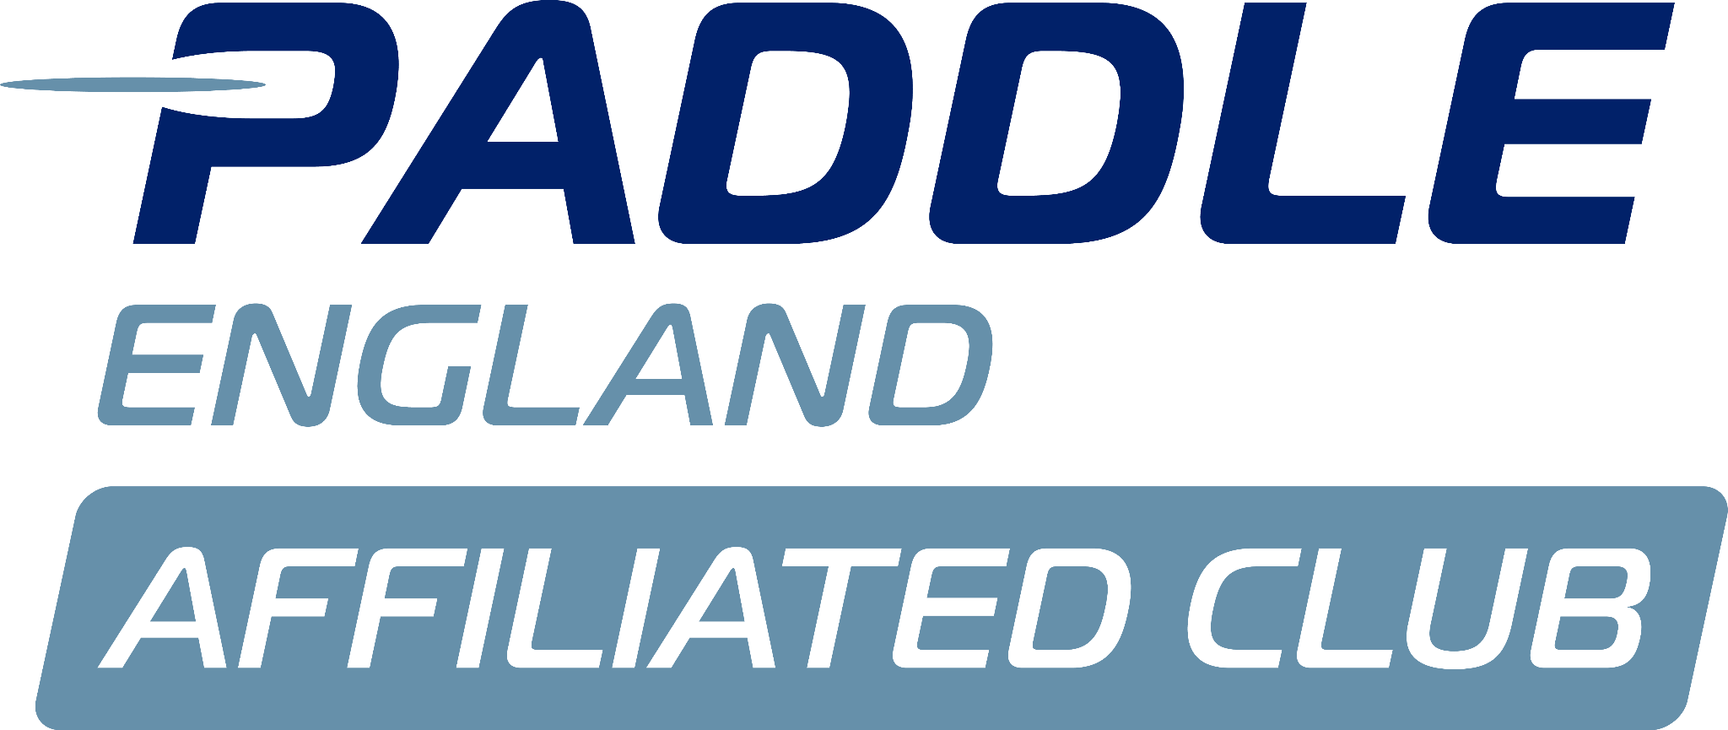
Monday 10th February

Present:
Sarah Walker- Chair (SW)
Matt Lodge- Vice Chair (ML)
Megan Broadey- Secretary (MB)
Charlie Peck- Adult Rep (CP)
Dyson Pendle- Director of Coaching (DP)
Alex Booth- Social Rep (AB)

Apologies:
Anna Carrington
Aaron Widdows
Tammy Edwards
Jo Davis
John Frankland
Shaun Cook
Flo Duffield

Minutes agreed by committee.

No matters arising from previous minutes.

Actions from previous minutes:
Screens for ergos: DP- have ordered and received the parts £1200 not £4000. Sent invoice to AW.

BUCS: DP- need parts, budget of £200- ordered the buoys and received £176- will invoice AW.

Fittings for ergos (seats): DP- invoice will be sent.

Social membership: DP- Tammy sent a draft document.
ACTION CP, DP and TE to review.
DP - Round social membership to £60- Committee agree.

Conflict of interest:
N/A

Suzanne's Report:
Suzanne had a query regarding how we use member data collected through LTK.
ACTION ML to send Suzanne policy.

Tims Report:
N/A

Welfare Reports:
N/A

Health and safety reports:
DP- Tim S has been sending documents over to Steve Mableson to get checked for BUCS.

Issues from coaching meeting:
N/A

Membership report:
N/A

Finance:
AW not present to run through accounts.

ML
- BC have sent surfski project money: £2k.
- Due to membership changes, money coming in is less than normal. People not sending correct direct debit.
ACTION TE send reminder to members re changes.
- AW has paid for the nationals car park

Newsletter:
SW- Is someone able to take over the newsletter?
- Tabby had offered to support but have not seen/heard from her to follow up.
ACTION CP to chat to Tabby about her availability.

Portage update:
SW- Need ecology survey and planning permission
- Looking to get 2 quotes for drawing, 2 quotes for survey and 2 quotes for the work
- Biodiversity net gain regulation survey- need to be careful, can only do 25 square metres of work without getting this survey.
- Have asked the broads authority to strim the bank, not yet got permission.
- Wanted to get everything done ready for application to be made in March
DP- How much is planning permission and survey.
SW- £350, £960 +vat, £50 permit to work.
ACTION- DP to send drawings of gas pipes/electricity to SW.

SW- £10500 including VAT at the moment.
DP- Could we ask MRC to contribute as they commented on it at a previous event following feedback.
ACTION SW to email MRC.

The committee agrees with work. The committee agreed a £1500 budget on fees etc.

Celebrating club achievements:
AB- 10 years in the clubhouse this year, could we have a celebration. Members don’t know the extent of the club's achievements.
- 45 years next year since the club was formed.
- Shall we do a practice run this year for 10 years?
SW- Summer evening bbq, do a quiz and presentation with maybe summer games.
ACTION AB/CP 5th July create a plan for the event.

EAAA visit:
AB- Was a successful evening, possibly running it again in the future.
SW- Thank you for organising.
ACTION AB to contact WBH re changes/improvements to be made to defib.

NCC CIO Membership:
AW not present to discuss.
ML- CIO is now going to become a partner of the boathouse.

Norwich Hasler:
ML- Want to keep entry fees the same.
DP- How does it compare to other clubs in the region?
ML- Not sure, need to find out.
ACTION ML to research other clubs hasler fees.

ML- Want a budget for food, will speak to AW
- Can AB do the medals?
AB- Yes-
ACTION ML to send details to AB.

Coaching list:
ML- Haven't got anywhere in a policy regarding what you must have as a coach to be paid.
MB sent policy (Coach Development) to ML.
SW- Think that everyone needs to be up to date before they do any sort of coaching.
- Put coaching payments on newsletter- committee agree.
ACTION SW to include Coaching payment structure in newsletter.

AOB:
Matt P step down:
- AB to contact Jon Blanchard

ACTION- Send code of conduct out to committee for review.

