Norwich CanoeClub
Committee Meeting
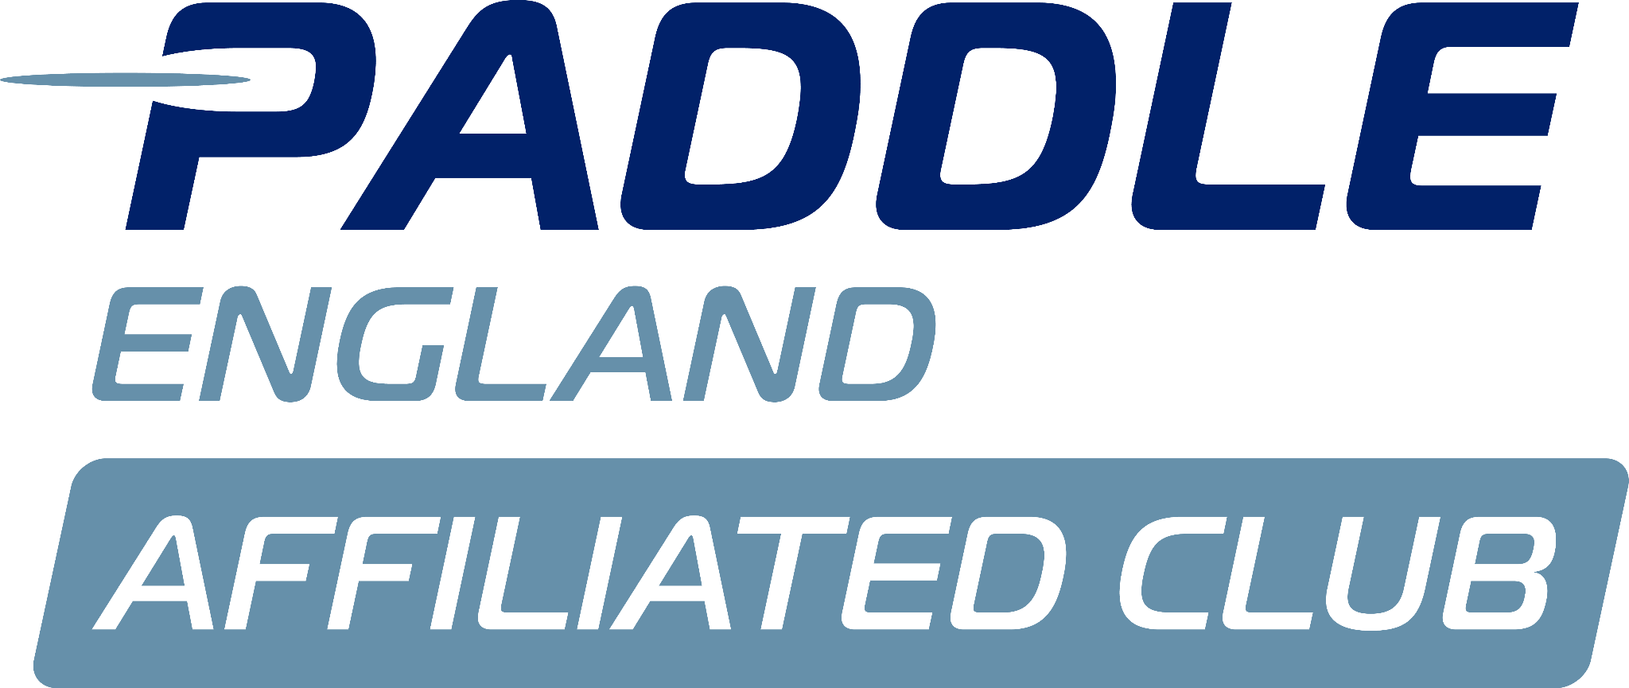
Monday 8th December

Present:
Steve McAulay
Matthew Lodge
Megan Broadey
David Walker
Anna Carrington
Dyson Pendles
Charlie Peck
Tammy Edwards
John Frankland
Eva McAulay
Katy Walker

Apologies:
Shaun Cook

November minutes agreed by committee.

Matters arising from previous minutes:

Actions from previous minutes:
See action log.
Conflict of interest:

Louise’s Report:
Not received.

Tims Report:
Not received.
SMc:
- Is meeting with Tim weekly- to get him working with us more smoothly.
AC:
- Are contracts changing?
SMc:
- Will confirm with them this week.

Welfare Report:
JF:
- Handing over with DW, the metal cabinet unlocked multiple L2K forms accessible.
- Moved them to a locked cabinet in the office.
- Spoke to TS, he's aware and is letting coaches know to be aware.

- Ian Copeland's funeral, this Thursday.
AC:
- Can share on facebook to wider members.
JF:
- Sent card on behalf of the club.
- Should we send something?
- ACTION JF confirm with family if there is a donation link.

Health and Safety Reports:
DW:
- The state of where we keep our boats, suggestion of a spring clean.
- ACTION DW to confirm a date.
ML:
- Jackie has said the gas man won't look at the boiler in the current state of the room

DW:
- Do we have induction packs?
DP:
- Yes, Tim created one this year.
TE:
- Sent out as part of the welcome letter.
- ACTION TE to share with DW.
- ACTION TE will reshare to facebook.
- ACTION MB will reshare in newsletter.

DW:
- Trailer checklists, remind people they need to complete the checklists before they take it and when they return it.

L.

DW:
- Access to the risk assessments on drive.
- ACTION JF to show DW.

No incidents
Issues from coaching meeting:
None.

Membership:
TE:
- 201 members.
- One junior member is going to leave.
- Multiple people have raised this, how can we adapt things to make things more accessible.
SM:
- Can welfare look into this.
TE:
- Offer support personally.
- Maybe offering a buddy system can help when I’m here but not always.

EM:
- Can get me or Tom to support, or approach another member, how old is she?
TE:
- Around 16, same as other members who also have the same struggles.
ACTION TE to pass onto EM/TR.

TE:
- New adult member to chase.

Committee agree that its really positive membership is improving and maintaining.

TE:
- Important to encourage all the families to join and attend, keep them engaged.

- MyClubhouse, Sam Fowler has suggested he could set up something similar to MyClubhouse.
  - MyClubhouse is good but has a lot of features we don’t need.
  - He’s been drafting something that we could potentially use.

MB:
- Matt P is meeting with him on the 20th December.
- ACTION SM, and TE to try and attend.

CP:
- We’re at a single point of failure, are we just moving that to someone else.

SM:
- He is very keen and is open to working with us.

CP:
- Do we need to share the knowledge so more people can make changes etc.

TE:
- Concern hes not on the committee, how much is going to have access to membership details etc.
MB:
- No different to how we have run with Matt, will have to do our due diligence.

AC:
- Ask Sam to set up the Whatsapp- how it works etc.
ACTION SM to bring up to Sam.

TE:
- Payments are up to date, AW has shared recent statement
- Some people haven’t updated renewal form. ACTION TE to share details, MB to chase.

Finance
Aaron not present.

Safeguarding:
MB:
- All committee members need ‘Paddle UK’sIntroduction to Safeguarding Course’

TE:
- All committee members need to have a Paddle UK membership, can add non-paddlers as associate members.

SM:
- Ensure all coaches have safeguarding training inline with Paddle UK.

MB:
- Confirm if we pay upfront for Michelle to do the courses or if she needs to pay and then we reimburse. Committee agree either way.

DP:
- DW to do safety management Event course.
- ACTION JF to share with DW.

Online meetings:
MB:
- Some members can’t make meetings and need to make it more accessible.

SM:
- Say we have it always available, to encourage more people to attend.
- Use Zoom.
- Encourage people to attend in person, but offer zoom.
COMMITTEE AGREE.

Kitchen rota:
TE:
- Emailed Coral with a list of membership, who goes on and who doesn't.
- Might be a good time to refresh, newsletter with the townhall.
SM:
- Why can’t 16+ be part of the kitchen rota.
- ACTION SM take this to Jackie.

MB:
- I’ll compare the coaches list to who goes in the kitchen, to let Coral know who else could go in.
ACTION MB.

TE:
- Make people aware they can buddy up to split a session.

Sprint/Marathon Rep chats:
SM:
- Creating more of a club focus.

KW:
- Spoken to some of the coaches, and parents already, so will encourage that.
- Want to encourage more crew boats and big lake sessions.
ACTION KW speak to juniors/coaches to understand what category theyre in.

DW:
- Use the screen for communications, to share what we can do.

ML:
- Doing a family gathering on a Wednesday a month to explain things to parents.
- ACITON KW to share rotas to try and get to attend.
- ACTION EM and TR.

AOB:
SM:
- Offer a townhall to members, to raise things that are being sent out via newsletters/facebook.
The committee agree with this idea, every quarter.

ACTION ADD AGENDA ITEMS:
- Marathon
- Sprint

DP:
- All things we did (special events), some of those events only 1 committee member attended. If we put an event on more people from the committee should attend.
KW:
- Dates need to be sent in advance, to encourage more people to attend.

Need to make sure the committee is up to date, and welfare officers across the boat house so we are more present.

DP:
- Oxygen £1800, do we know what it was?
SM:
- A course,how aerobics works, it is a grant.
- 2 people can go on the course.
- Tim wants to go on, maybe Ian Hayward. Makes sense for Tim to go.
- They will go to Ireland and fund it themselves, to attend in person.

KW:
- Is he running consistent sessions?
SM:
- No trying to encourage him to attend.

JF:
- Who is running Portugal?
MB:
- Me, will share details with JF and DW.

ML:
- Do we want to get rid of the old Langley trailer?
DP:
- We could take the V’s off and flog the trailer?
ACTION DP to do.
ML let Jackie know.\

Need to put some pictures up.
ML ACTION 35 budget

ACTION AC to share IG details with EM and KW.

EM:
- Girls changing rooms, need a period box?
- Can we approach WBH about it.
ML to speak to Jackie.

SM:
- Putting pigeon holes in changing rooms, to put your bag away when you’re not using. I have spoken to Rosco, will continue with WBH.

SM to speak to Jackie about the boards.

End of meeting, date of next meeting 12th January.

