Norwich CanoeClub
Committee Meeting
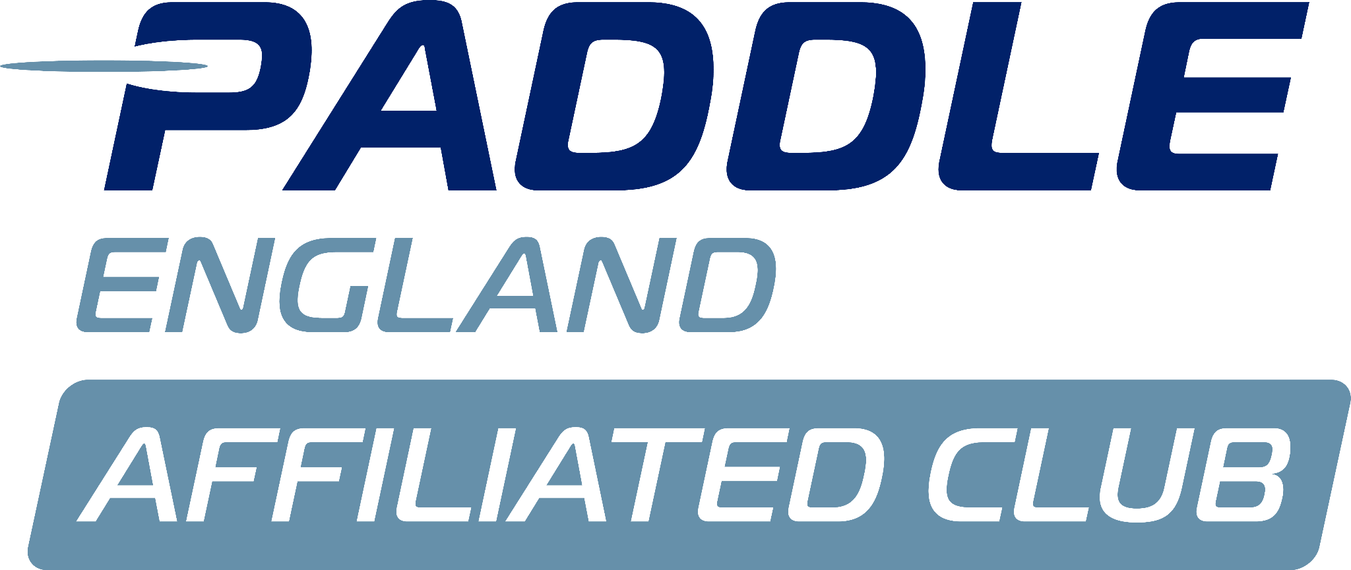
Monday 11th August

Present:
Megan Broadey (MB)
Matthew Lodge (ML)
Sarah Walker (SW)
Tammy Edwards (TE)
Aaron Widdows (AW)
Charlie Peck (CP)

Apologies:
Dyson Pendle
Shaun Cook
John Frankland
Flo Duffield
Alex Booth

Minutes agreed by committee.

No matters arising from previous minutes.

Actions from previous minutes:

Conflict of interest:

Louise’s Report:
- Louise has not been recording required data (ACTION- SW to follow up).
- Some positive contributions outside her remit noted.
- Review of Wymondham College sessions needed (previously longer, more effective).
- Louise indicated she can support in winter but is uncertain for next summer (to confirm in writing).
Committee agreed role is currently unsustainable without greater pay/structure.
Tims Report:
Sam Fuller
- Committee agreed the training programme format should remain unchanged. Should be posted on the website.
ACTION – MB to liaise with Sam and Matt Parkes re digital responsibilities.
- Committee approve 3-month trial of MyClubhouse for membership, training schedule upload etc.
JDS Camp
- Costs confirmed by AW; NCC to receive roughly £600.
Beach Day
- Participants must sign a disclaimer (non-club event, not insured).
ACTION – SW to request Tim provide a disclaimer form and seek committee approval in advance of future events.
Welfare Reports:
N/A

Health and safety reports:
- Several racing incidents were raised; one paddler appears central.
- Investigations must be committee-led, not handled by individual coaches, and should be requested by someone involved in the incident directly.
ACTION – SW to raise with Steve M.
Estelle’s incident with rower was discussed; members reminded that any issue that is safety-related should be formally reported.

Issues from coaching meeting:
N/A

Membership report:
- 55 renewals outstanding; 4 confirmed non-renewals.
- Membership growth: +23 (June), +9 (July).
ACTION – TE to email LTK course attendees re joining.

Finance:
- Nationals: income ~£15k, costs ~£3k (car park not profitable).
- Membership income increased to £47k (from £42k); grant income also up.
- Cash balance end of July: £95k (£61.5k in deposit, incl. £50k reserves).
- New accountant identified to verify accounts.
- AW to remain trustee despite stepping down from treasurer role.
ACTION – AW to send AC list of treasurer tasks for quotes.

Nationals:
Thanks recorded for Sarah.

Winter Team Events:
Committee agreed to introduce ~6 winter social events for juniors.
ACTION AC/MB to look into Christmas Party.

AOB:
First Aid Request from Dereham
- Dereham requested details on any upcoming courses we are aware of.
- 8-hour course link to be circulated (CP).
ACTION – MB and ML to arrange a 16-hour course for those who require it.

End of meeting, next meeting 8th September.

